**Solution description:**

AI Recruiter Bot welcomes a brand new era of recruitment protocol.

One of the most challenging problem statements given by IBM HACK CHALLENGES TEAM.

**THEME:**

An interface where computer can able to interact with candidates and select the most efficient pupils as a part of general recruitment.

**Solution:**

* We are going to create an Artificial Intelligence enabled BOT, which thinks as human, acts as human, and react like human.
* So for this approach we should also have a keen eye upon those candidates who are appearing for interviews multiple times so our solution should eliminate this problem.  So we are going to develop **a machine learning model to identify person by image processing.**
* Our solution should able to provide chance for each and every candidate who appear for interview.
* Our bot should able to provide two levels of screening, one for technical skills, and another for communication skills.
* Majorly we have to focus on communication skills, so for that purpose, our bot should able to provide voice based communication from either sides.
* Optional MCQ based test is available if recruiter specifically wants to filter.
* We will also provide login option for both candidates and recruiters as well such that each and every stake holder will have their own account, and eligible candidates will get notified about opportunity.

**Novelty or uniqueness:**

**Uniqueness:**

* **Avoid multiple participation of candidate.**
* Able to provide unique voice based communication to classify based on communication skills.
* Our bot should not only provide recruitment facility for IT field, but also it should provide recruitment facility for other fields like civil engineer, mechanical engineer, electrical engineer, etc. In one sentence**a multi-purpose recruitment bot.**
* We have to engage some **uniqueness**for our recruiter. So for that purpose, we are going to**provide a unique form in favour of recruiter's team, so that they can specify the constraints of recruitment.**As per theconstraints given by recruiter's team, our bot will manage the recruitment process dynamically.
* Questioner prepared with the help of some known real time recruiters of mine, so there would be perfection in questioner.

**Expectations:**

* Able to segregate candidates according to their level of standards, such that recruiters can able to sort out candidates effectively.
* Spontaneous rejection of candidates who have low level of standards

**Business or social impact:**

* AI enabled BOT can able to segregate candidates efficiently.
* Able to attract bunch of MNC's and STARTUP's as well.
* Can make commercial income if we plan for a paid version of services.
* Able to provide a mystic bridge between recruiters and talent blazers of modern world.
* Easy to handle interface can attract multiple customers.
* No company looses the right candidate and no candidate losses the right company.

**Technology Stack**

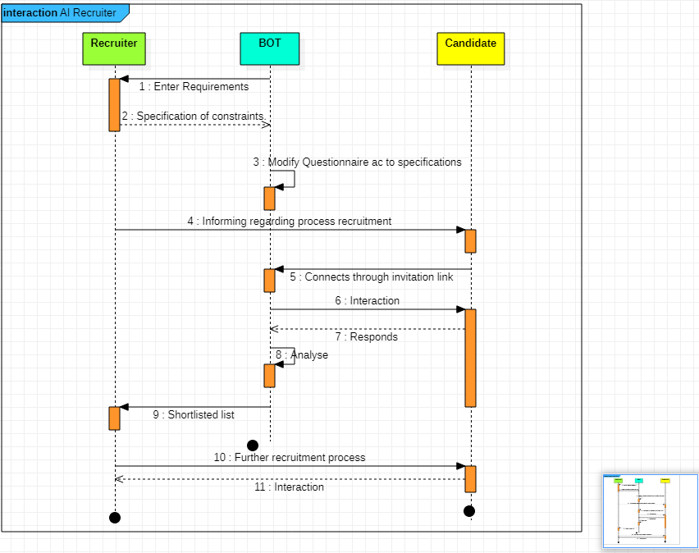

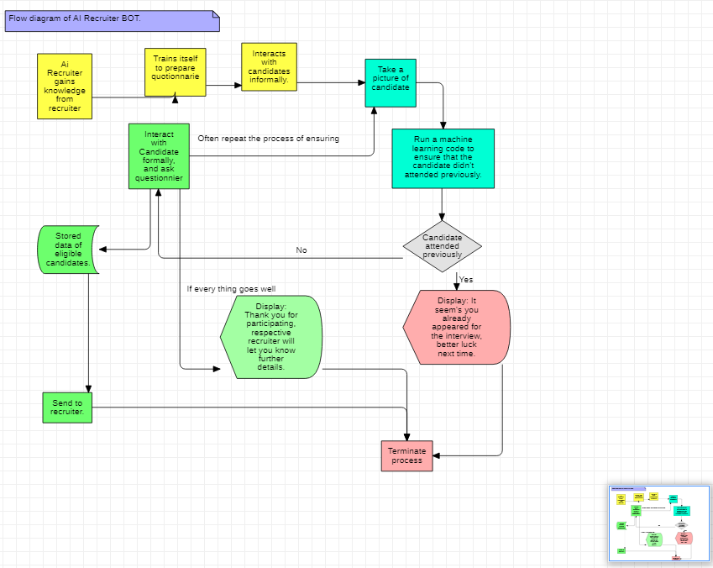

**Scope of work...**

/* define the scope of work to be implemented in the project with modules etc. */

**Phases of BOT Recruitment.**

* Resume analysis.
* LinkedIn activity tracking using **Web scraping.**
* **Certificate confirmation**of online courses taken by candidate if any? Using the same web scraping as well.
* Repeatedly checking foe candidate conformation against repeated participation in regular intervals by algorithms like image processing.
* Enabled voice recording so that a recruiter can have second opinion of his best.
* Voice based communication to ensure fluency of language using some speech recognition modules like **google speech API.**
* Formal questioner.
* Optional MCQ's and/or programming tests if specially required by recruiter.
* Segregation of talent blazers according to their level of talent’s.
* Report to recruiters and team.
* Formal feedback form.